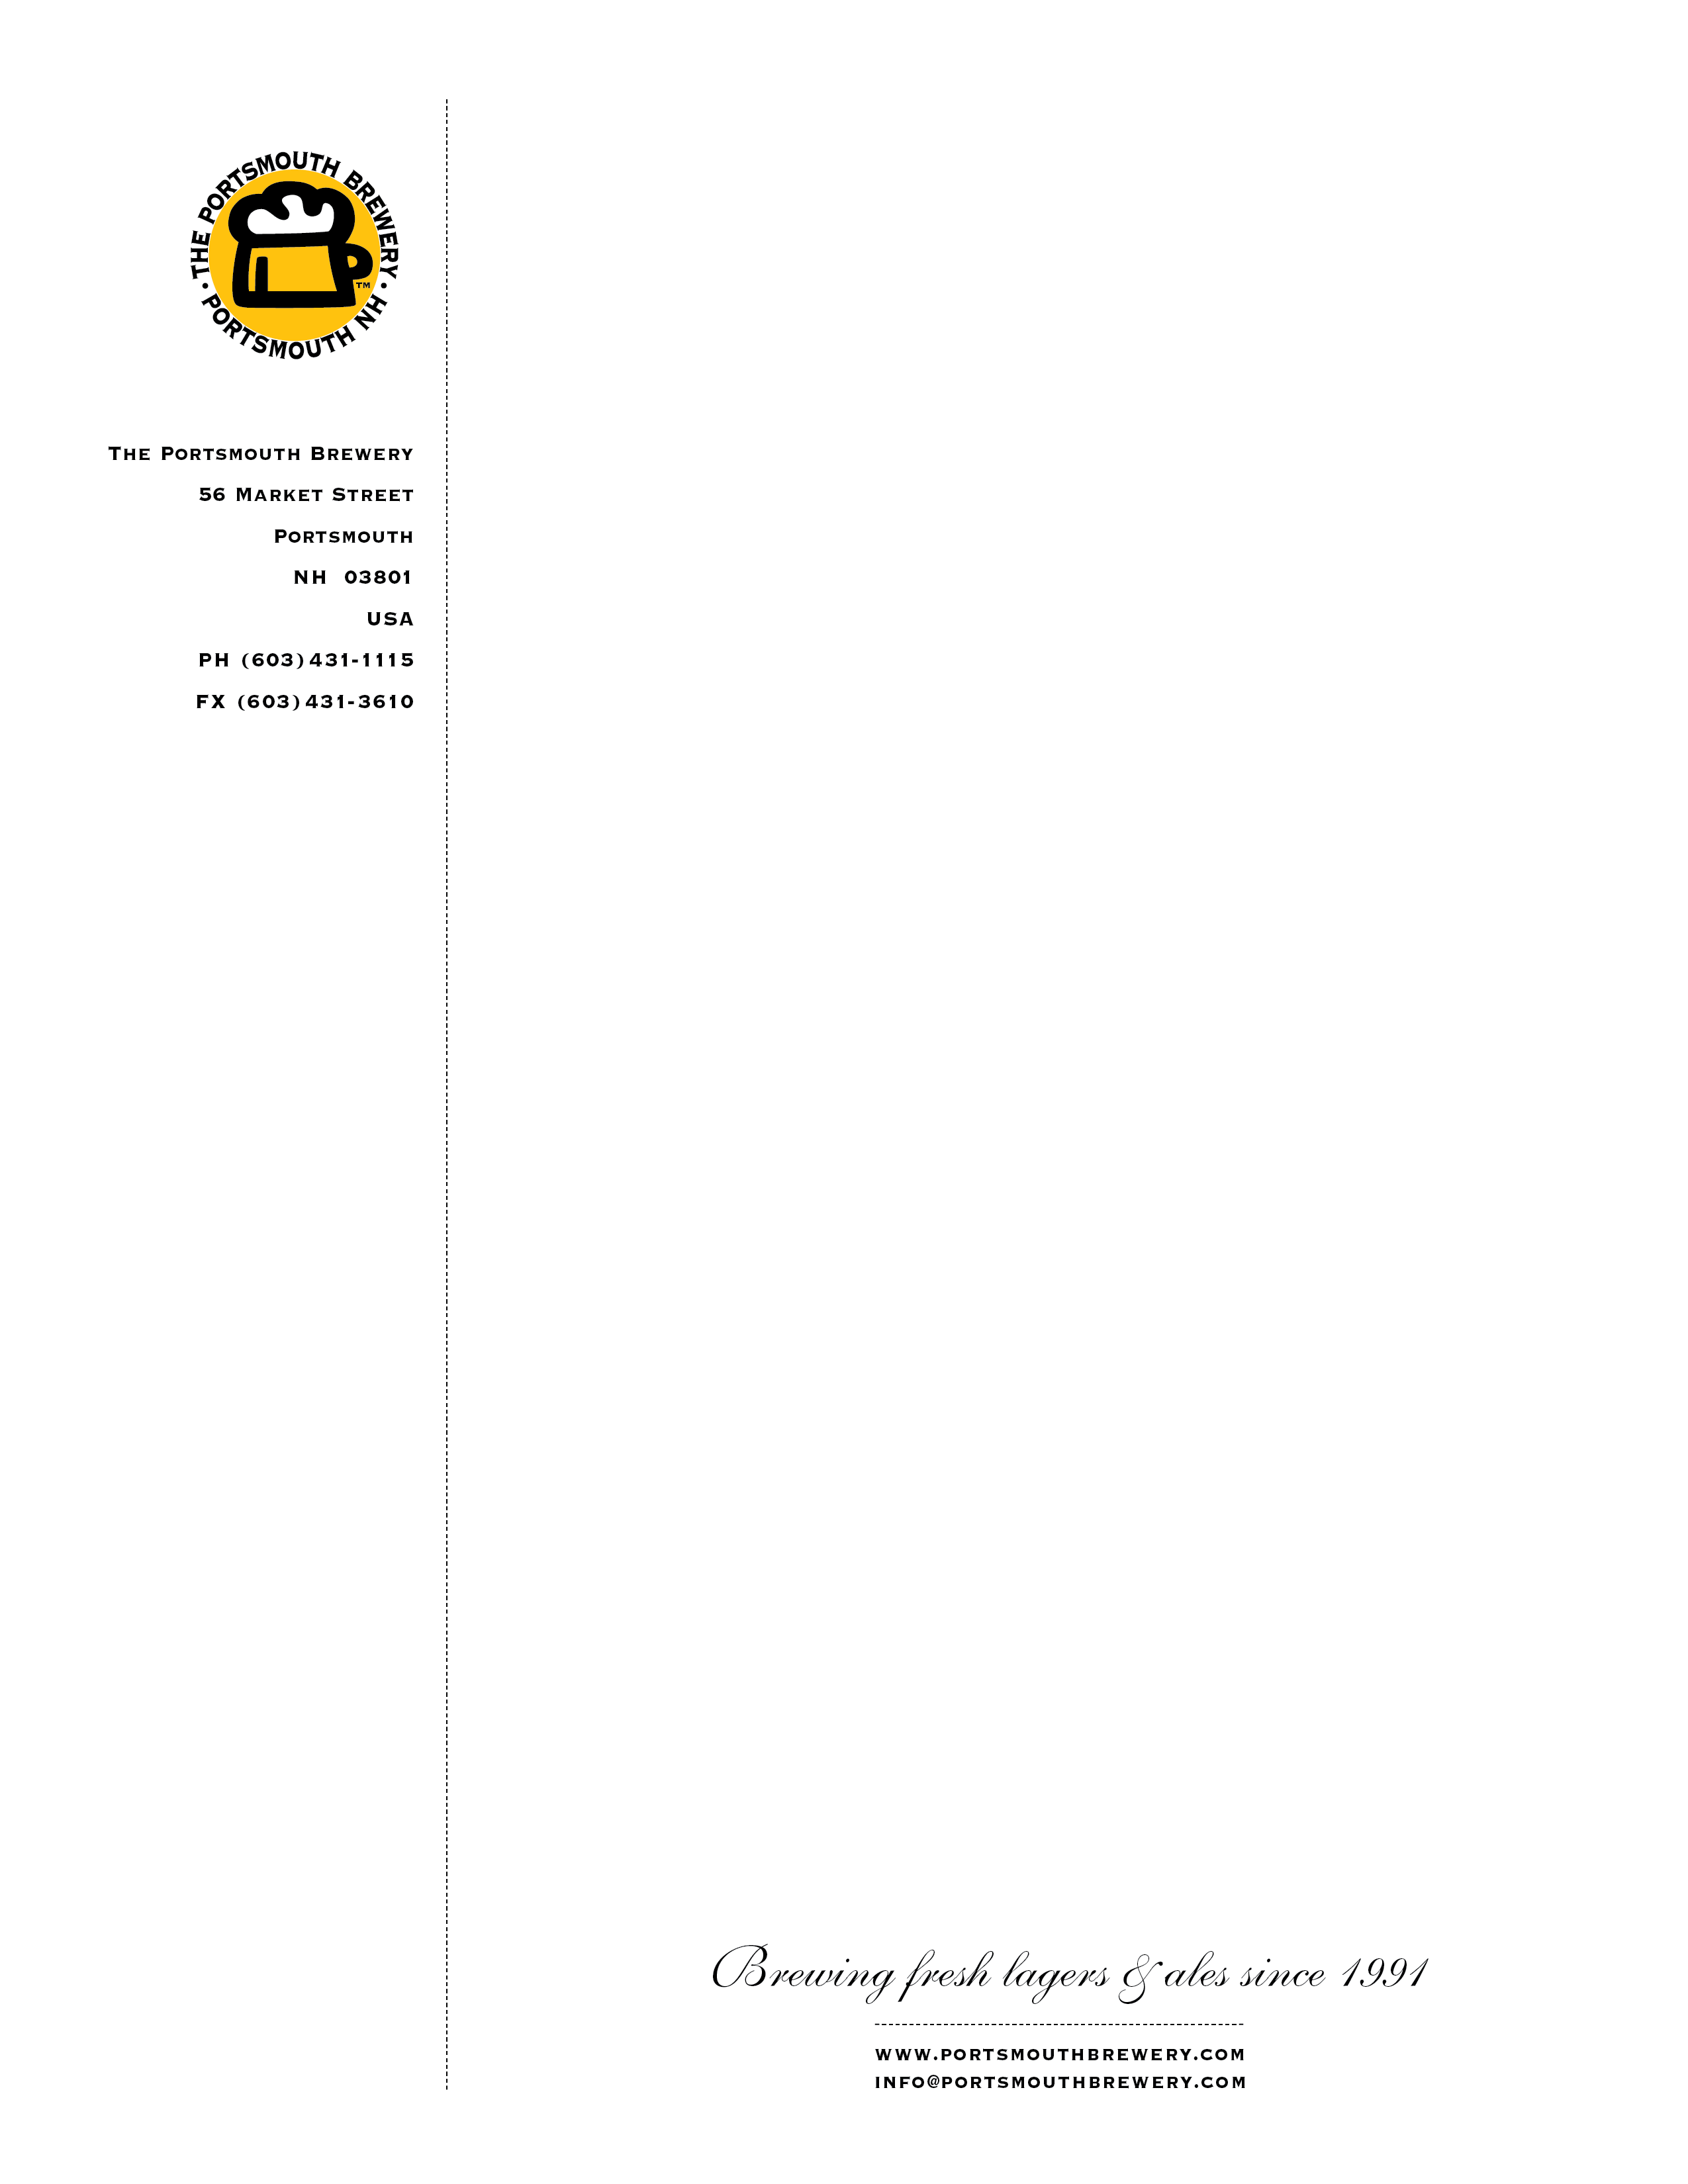
The Portsmouth Brewery: New Beer "O'Dark Hundred" Benefits Local Charity "Hero Pups"

PORTSMOUTH, N.H. — The Portsmouth Brewery, New Hampshire’s first brewpub, is honored to partner with the Black Ale Project, a craft beer initiative that raises money and awareness on behalf of U.S. war veterans. The Portsmouth Brewery is the first New Hampshire brewery to sign on to the project; it will join the ranks along with the other
34 other breweries nationwide that have supported the cause.

“As a former Marine and non-combat war veteran, I just couldn't read news article after news article about the plight of our veterans without doing something to help,” said Dave Pappas, founder of the Black Ale Project. “It is truly an honor to have The Portsmouth Brewery represent the Black Ale Project…I hope to continue to raise money for veteran charities located in the very same communities as the breweries making beer for the Black Ale Project, while also raising awareness for veterans with every glass of beer that is poured.”

Matt Gallagher, Head Brewer at The Portsmouth Brewery, has
worked with Pappas to brew a special Schwarzbier called “O’Dark Hundred” for the Black Ale Project. Set to hit the taps by the end of October, a portion of the proceeds for each pint purchased will be donated to Hero Pups, a charity that pairs service dogs with veterans in the Seacoast.

***********

The Portsmouth Brewery is New Hampshire’s original brewpub, serving great food and outstanding handcrafted beers in a friendly, lively atmosphere since 1991. Their 56 Market St. location in downtown Portsmouth has served as a popular hub for locals and visitors looking to unwind in a space where they’re treated like family. Select Portsmouth Brewery bottled beers are available in their retail store attached to the restaurant.

